**Software Requirements Specification**

1. Nasim Adabi

ID : 40079444

E-mail: [nasim.adabi@gmail.com](mailto:nasim.adabi@gmail.com)

1. Mahshad Saghaleini

ID: 40058409

E-mail: [mahshad.saghaleini@gmail.com](mailto:mahshad.saghaleini@gmail.com)

1. Nandini Bandlamudi

ID: 40105415

E-mail: [bandlamudi.nandini@gmail.com](mailto:bandlamudi.nandini@gmail.com)

1. Venkata Pavan Kumar Reddy Ravi

ID: 40083392

E-mail: [pavan.03121996@gmail.com](mailto:pavan.03121996@gmail.com)

1. Hina Masood Ahmed

ID: 40076287

E-mail: [m.hinathahseen@gmail.com](mailto:m.hinathahseen@gmail.com)

1. Swetha Chenna

ID: 40092019

E-mail: [swethachenna2018@gmail.com](mailto:swethachenna2018@gmail.com)

1. Kiranmayie

ID: 40092284

E-mail: [2809kiran@gmail.com](mailto:2809kiran@gmail.com)

1. Sahana Shankar

ID: 40092026

E-mail: [sahana15shankar@gmail.com](mailto:sahana15shankar@gmail.com)

**Abstract:**

The system is a web-based application where one can buy tickets with just one click go. An internet user can buy tickets. Also, in the system, if the customer wishes to cancel his tickets he will be given a confirmation details regarding his cancellations. As the customer buys tickets online through his credit card. All the customers have to register and become a member before buying tickets so that he faces no problem while accessing the website.

# Introduction

This document will provide a detailed insight of the online movie ticket selling system.

## Purpose

The purpose of this document is to present a detailed description of the system. It will explain the purpose, the features and the constraints of the system, the exposed interfaces, the conditions under which it will function and how it will react to different inputs. This document is intended for the instructor, the Teaching Assistants and any developers planning to implement, maintain or service this library system.

## Scope

This document concerns the User and Media management for an online movie ticket selling system. It influences the way the data is handled and how the system must interact to external stimuli. More specifically, it will explain the methods used to maintain the media and user catalog, perform and display queries and handle user-media interaction.

## Definitions, acronyms, and abbreviations

|  |  |
| --- | --- |
| User | Any person (both physical and intellectual) that will use the library system |
| Administrator (Admin) | A user that holds special permissions and limitations |
| SRS | Software requirement specification |

# Overall description

This section describes the background to the requirements: The general factors that affect the product, such as constraints, assumptions and dependencies.

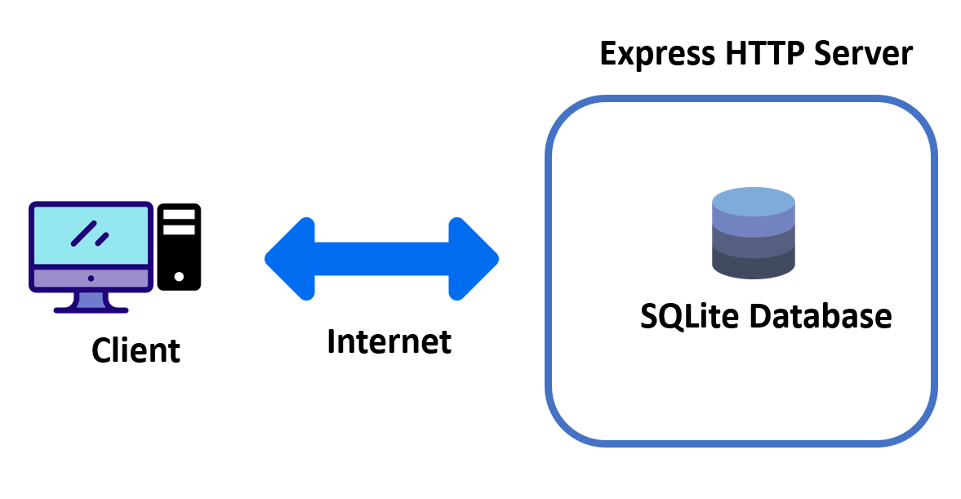

Figure 1. A client-server architecture.

## Product perspective

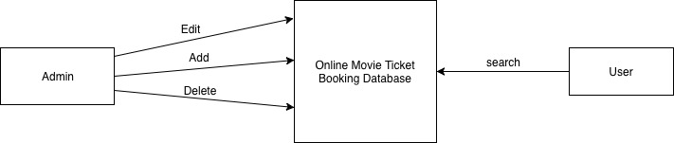

Figure 2. Object perspective

## Product functions

This system is an online web application for users to be able to purchase their ticket for a movie. In the application, there are two kinds of access for the users. First, there is a user with an Admin access who have access to add or delete a movie. Second, there is a user with a Customer/Client access who is able to view the list of movies, select their choice and receive the ticket.

For both above mentioned user types, first user must register in the system with a unique email address. Then, they must login in order to be able to buy a ticket.

## User characteristics

Intended user of this system can be anyone who has a basic knowledge of the internet and web pages. They don’t required to be expertise. They only need to be familiar with online purchasing on the internet.

## Constraints

Describe any items that will limit the options of the developers (such as regulations, hardware limitations, safety and security etc.)

## Assumptions and dependencies

For running this application Java EE with the minimum 0.0 version and MySQL database with the minimum 0.0 version is required.

# Specific requirements

**User Module**

**User Requirements**

* Registration

User registration is required to book the ticket. An unregistered user cannot book the ticket.

* Login

User should give valid login credentials.

* Decide the movie

The user can see list of movies with show date, show time and venue. User can select the movie from the movie list.

* See the ticket availability

After selecting the movie, the user can see the ticket availability. If ticket is available, user can book the ticket.

* Seat Selection

User can select the desired number of seats with his credentials and a confirmation message is shown on the system.

* Add and Remove Changes to Cart

User can add or remove the number of tickets.

* Ticket Cancellation

The user will be given an option of cancellation before the payment process.

* Payment

The user can pay for the ticket using credit card, The card is validated and a confirmation message is shown on the system.

* Logout

User should be able to logout from the system.

**Admin Module**

**Admin Requirements**

* Login

Admin should give valid login credentials.

* Add and Remove Changes to Movies

Admin can add or remove the number of movies.

* Logout

Admin should be able to logout from the system.

### External interfaces

For login page, a valid user id and password is required.

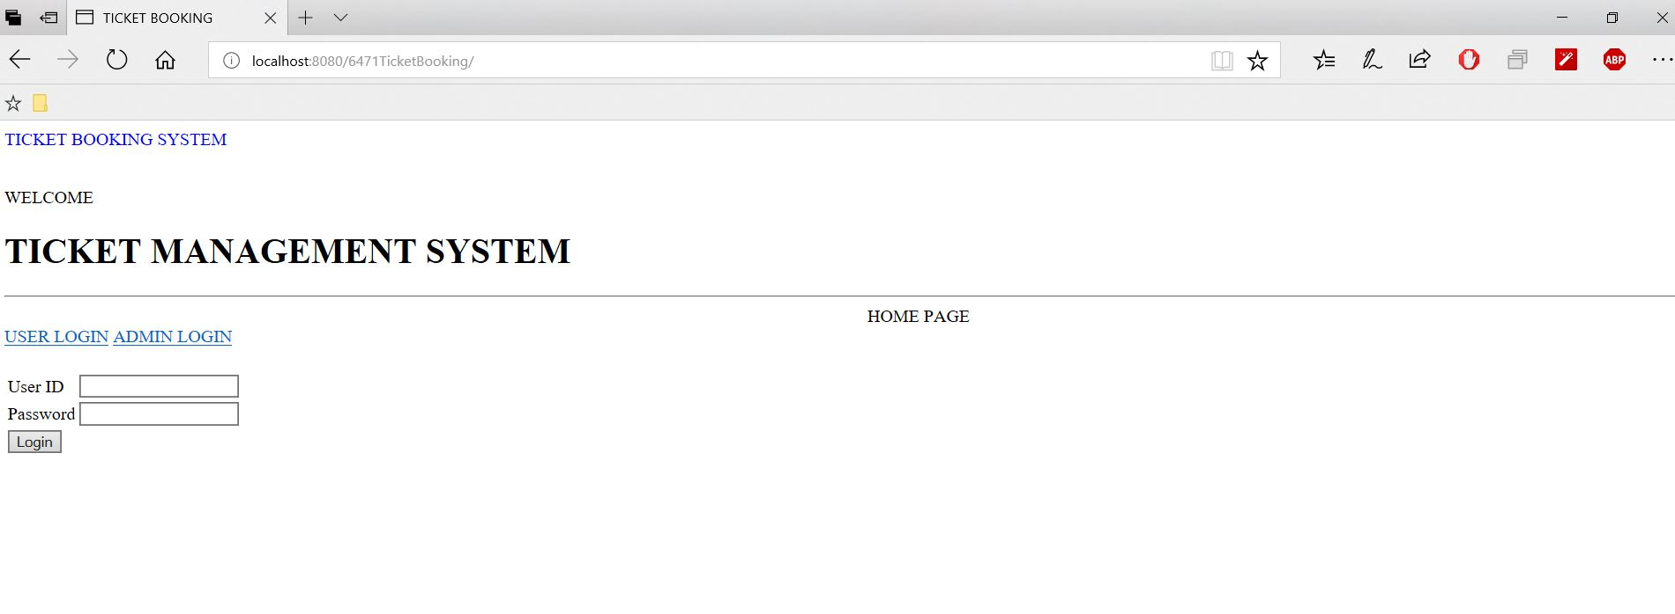

Figure 3.External interfaces.

For booking a ticket, user can only enter the number of tickets manually. The rest of the fields which are Movie name, Time and Date, are proposed as options to the user in combo box and date component, in order to avoid user mistakes.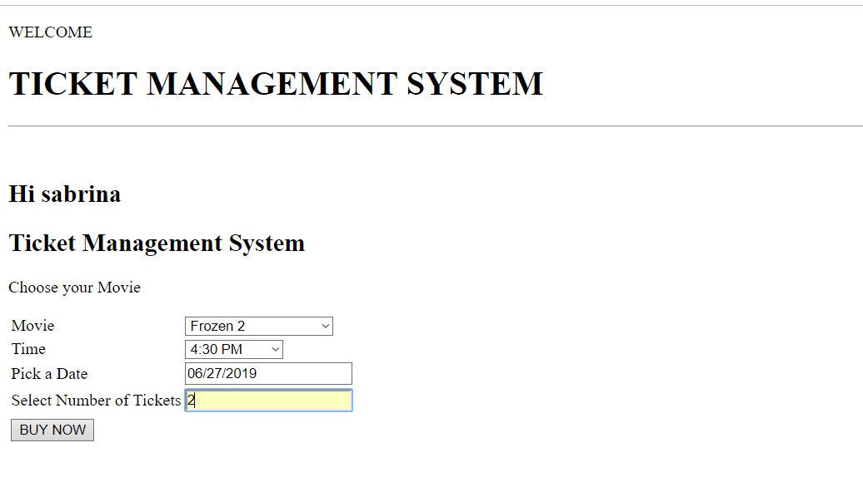

### 3.2 Functional requirements

#### Actor goal list

|  |  |
| --- | --- |
| Actor | Goal |
| Administrators | Add movie  Remove movie  Edit movie Info |
| Clients | Book and buy a ticket |
| Users | Log in  Search for movie  Pay for booking |

#### Use case view

The use case model is shown in Figure 4.

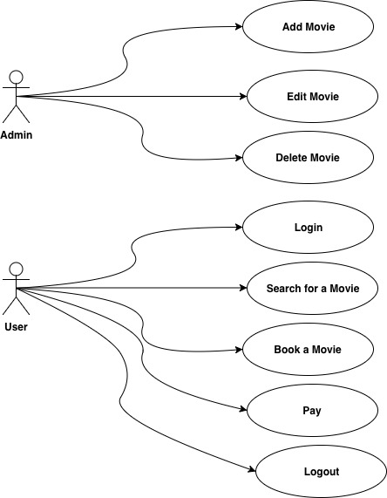

Figure 4. Use case model.

### 3.3 Non-functional requirements

#### Performance efficiency

The response of the system to the user’s query is fast and accurate and the system handle and validate large data in a short time.

#### Compatibility

The system is compatible with any browser that supports “HTML5” as specified by W3C (<https://www.w3.org/html/>).

#### Usability

Anyone with a web browser can use the online movie ticket booking system as long as they know how to read and write.

#### Reliability

The system is highly reliable since we do not saving user’s credit card information and referring them to the online payment bank system. Many users can access the system at the same time in less than 5 second waiting time. In the situation of two or more user trying to book a same seat there is a blocker that block that seat and just the one who access to it first can book it. The current limitation on the system’s reliability is dependant on the hardware and network used by the physical library that uses this system.

#### Security

Users needs to login to access the function of the system. Every user request requires system authorisation based on the user subtype (client or admin). All sensitive data like passwords are hidden inside the database, so we limit dangerous of system.

#### Maintainability

The system can be modified by referring to the existing documentation provided, Please note that any changes added to the system’s source code make sure the documentation needs to updated likewise.

#### Design constraints

All of the function for the system is written by Java and in the client side validations we used Java Script. Database is created by My sql language. The Architecture style used for this system is “client-server”. The implementation is contain five classes includes “user, admin, book ticket, movie, payment”.

# Analysis Models

**State Diagram:**

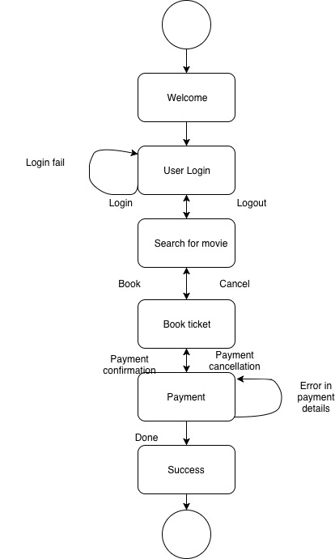

Figure 5. State diagram.

**Sequence Diagram:**

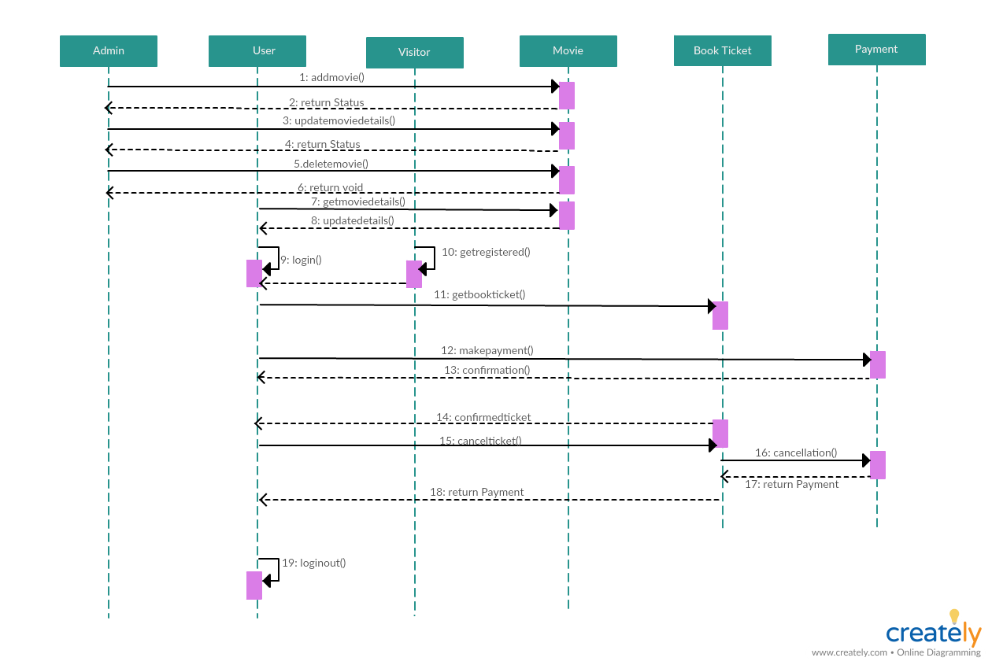

Figure 6.Sequence diagram.

**Package Diagram:**

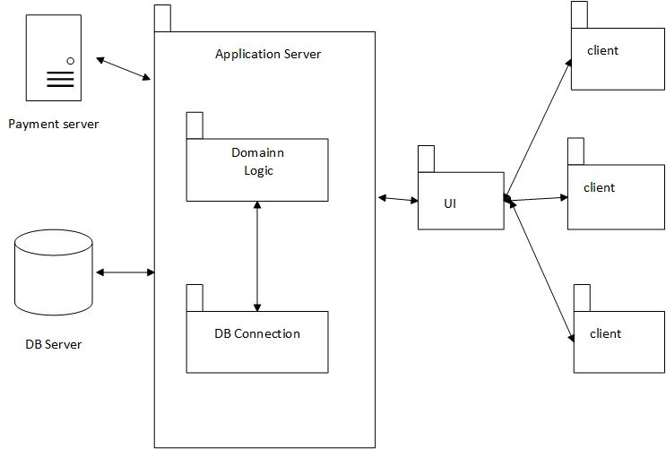

Figure 7. Package diagram.

**Component Diagram**

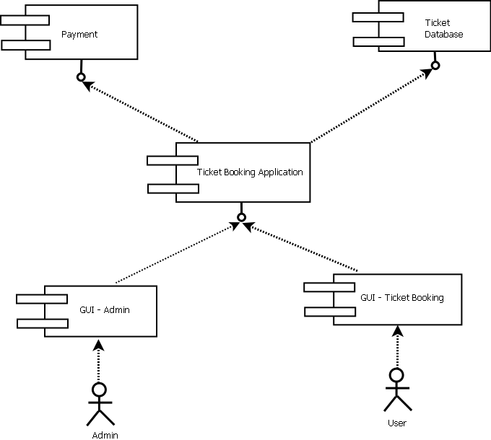

Figure 8. Component diagram.

## References:

1. <https://www.process.st/checklist/online-movie-ticket-booking-system/>
2. <https://www.academia.edu/31536019/MOVIE_TICKET_BOOKING_MANAGEMENT_SYSTEM_PROJECT_REPORT.doc>
3. https://www.techopedia.com/definition/438/clientserver-architecture
4. <http://apachebooster.com/kb/what-is-client-server-architecture-and-what-are-its-types/>
5. http://testingnotes.com/basic-characteristics-client-server-testing-architecture.html
6. <https://docs.oracle.com/cd/E13203_01/tuxedo/tux80/atmi/intbas3.htm>
7. https://cio-wiki.org/wiki/Client_Server_Architecture